**EXPERIMENT 6**

By,

**Raja Aadhithan**

**19/1031**

Write a MATLAB Script to design the FIR filter (low pass, high pass, band pass, band stop) using Window Method.

1. Rectangular

2. Hamming

3. Hann

4. Kaiser

**Code:**

clc;%clear console

clear;%clear variables

close all;%close all figures

n = 20;%order of filter

fp = 200;%pass band frequency

fs = 600;%stop band frequency

f = 2000;%sampling frequency

wp = 2*(fp/f);%pass band frequency in rads

ws = 2*(fs/f);%stop band frequency in rads

window_1 = boxcar(n+1);%rectangular window

window_2 = hamming(n+1);%hamming windoe

window_3 = hanning(n+1);%hanning window

window_4 = kaiser(n+1); %kaiser window

%attaching all the doubles to use in loop conveniently

y = [window_1 ,window_2 ,window_3 ,window_4];

%to be used in titles

name = ["rectangular","hamming","hanning","kaiser"];

%ploting loops

for i = 1:4

window = y(1:n+1,i);%takes one window at a time

t = ["high","low","bandpass","stop"];%four different types of filter

for x = 1:length(t)

if x < 3

wn = wp;%single frequency for high and low pass filters

else

wn = [wp,ws];%two frequencies for band filters

end

b = fir1(n,wn,t(x),window);%filter function

[H,w] = freqz(b,1);%transfer function

figure (i)%individual figures for each window

subplot(4,2,2*x-1)

plot(w/pi,20*log(abs(H)));%magnitude

xlabel('normalized frequency');

ylabel('mag in db');

title ('mag response for ' + name(i) + ' as '+ t(x) +' pass filter ');

subplot(4,2,2*x)

plot(w/pi,angle(H));%phase

xlabel('normalized frequency');

ylabel('angle');

title ('phase response for ' + name(i) +' as '+ t(x) +' pass filter ');

end

end

**Output:**

Rectangular:

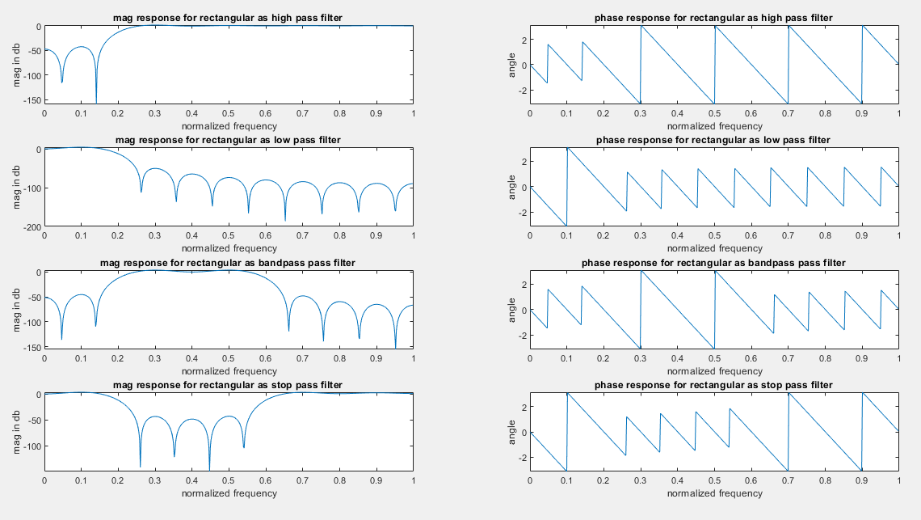

Hamming:

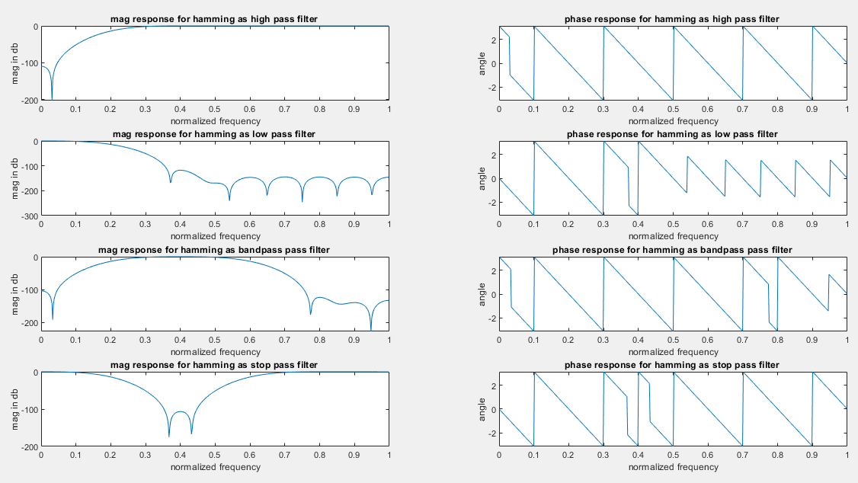

Hanning:

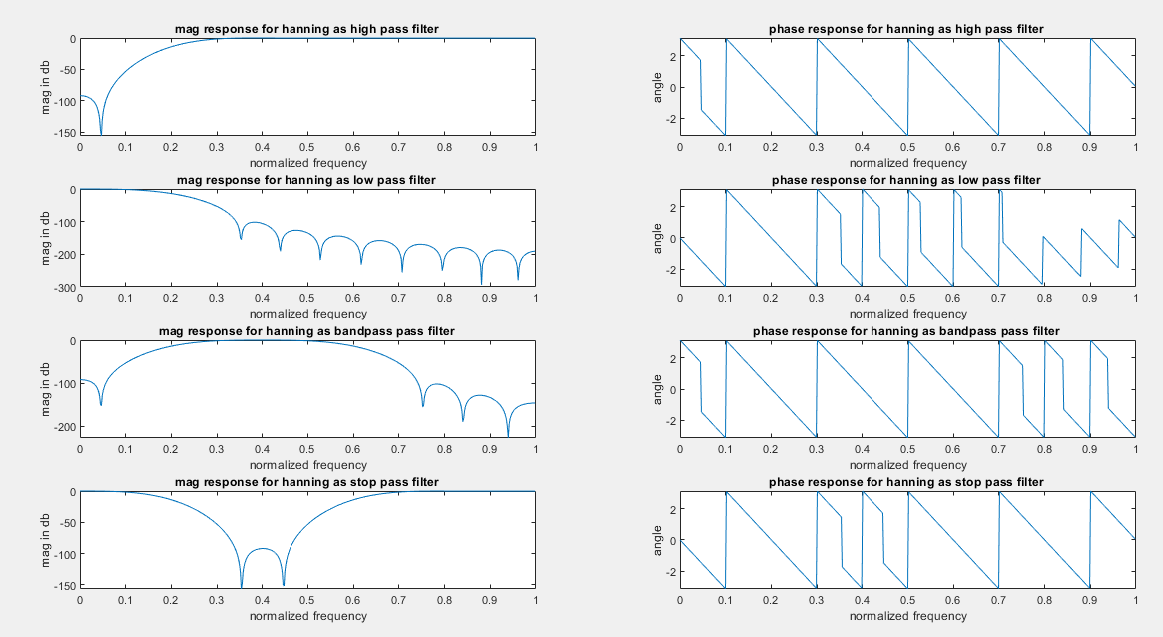

Kaiser:

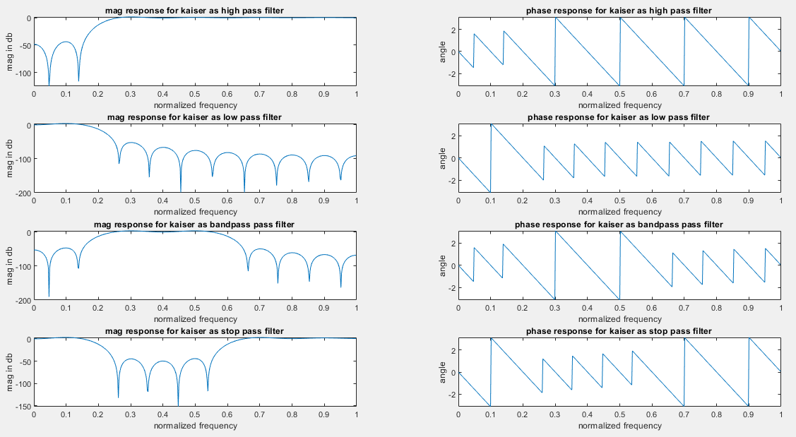

List of variables:

